January 30, 2017

Dear Drs. Averill, Ell, and Hunter,

We are submitting the manuscript “Teacher Preparation Does Matter: Relationships between Elementary Mathematics Content Courses and Graduates’ Analyses of Teaching” for consideration for publication in the Mathematics Teacher Education and Development Journal. This study explores relationships between a teacher preparation program and graduates’ knowledge several years after graduating. In the United States, teacher preparation programs are under pressure to demonstrate evidence connecting specific aspects of teacher preparation that result in graduates with critical teaching competencies, knowledge, and skills to be effective teachers. However, very little research demonstrates this kind of evidence. In a rare case, Hiebert, Miller, and Berk (in press) found that graduates of an elementary teacher education program tended to perform significantly better when analyzing videos of classroom teaching for mathematical topics specifically taught during their program compared to topics not taught during their program. This “analysis-of-teaching” task has been shown to be correlated with high quality teaching and, in turn, to students’ learning, by Kersting and colleagues (Kersting, 2008; Kersting et al., 2010; Kersting et al., 2012). Because this claim has significant implications for teacher preparation programs and policies and is rare to observe, we believe that this study warrants replication.
As such, our study replicates the analyses and methods used by Hiebert, Miller, and Berk (in press) with a different cohort of graduates from the same elementary teacher education program. We followed graduates into the field two, three, and four years after graduating. Each year, graduates were asked to analyze classroom videos for four topics: three topics taught during their program (target topics) and one topic not taught during their program (control topic). Using the same task, our results corroborate Hiebert et al.’s (in press) findings that graduates tend to score significantly higher analyzing target topics than the control topic.
Readers of the Mathematics Teacher Education and Development Journal may be interested in our study because our results strengthen the claim that teacher preparation programs can make a difference in graduates’ knowledge, competencies, and skills related to effective teaching, even several years after graduation. In addition, readers may be interested in the value and process of a replication study. We feel that it has been very difficult to support claims connecting specific aspects of a teacher preparation program to graduates’ teaching competencies several years post-graduation because of the multitude of factors influencing graduates’ knowledge. Yet one way to strengthen support for such claims is through replication studies, which have historically been neglected in education research (e.g., Schmidt, 2009; Smith, 1970). Therefore, readers may be interested in this method of validating a claim, especially a rare or surprising finding, such as those reported by Hiebert, Miller, & Berk (in press).
The text for our manuscript is currently at 18 A4 pages (just under 7000 words), including three tables and three figures that have been embedded in the text. This excludes the abstract, references, and appendices. We included our full coding rubric in an Appendix to allow reviewers sufficient information to judge our manuscript. However, we welcome feedback regarding whether this full rubric is necessary for readers of the Mathematics Teacher Education and Development Journal, if our manuscript is to be published in this journal. This paper has not been published or accepted for publication and is not under consideration by any other journal. In conducting this study, we complied with the ethical standards of the American Psychological Association.
Thank you for your consideration and we look forward to hearing from you and the reviewers about our manuscript.

Sincerely,

Siobahn Young

Joseph DiNapoli

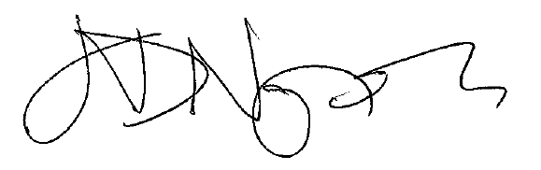

And Robert Mixell

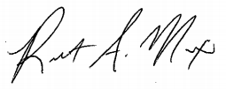

Authors
Siobahn Young
203 Willard Hall,
University of Delaware,
Newark, DE 19716
email: youngs@udel.edu

Joseph DiNapoli
203 Willard Hall,
University of Delaware,
Newark, DE 19716
email: jdinap@udel.edu

Robert Mixell
203 Willard Hall,
University of Delaware,
Newark, DE 19716
email: mixellr@udel.edu

