November 22, 2014

Dear Jodie Hunter, Glenda Anthony and Bobbie Hunter,

I am submitting a blinded version of a paper coauthored with Kjersti Wæge to be considered for publication in the special issue of Mathematics Teacher Education and Development on Practice-Based Teacher Education. We certify that this paper has not been submitted elsewhere for publication.

Our paper is titled, Learning to teach within practice-based methods courses, and our contact information is as follows.

Elham Kazemi
University of Washington
122K Miller, Box 353600
Seattle, WA 98195-3600
email: ekazemi@uw.edu

Kjersti Wæge
Norwegian University of Science & Technology
Norwegian Centre for Mathematics Education
7491 Trondheim
Norway
email: kjersti.wage@ntnu.no

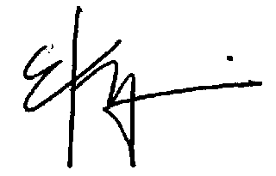
Sincerely,

Elham Kazemi
Associate Dean of Professional Learning
Geda & Phil Condit Professor of Mathematics Education
ekazemi@uw.edu
(206)221-4793

